IIFE – Immediately invoked function expression

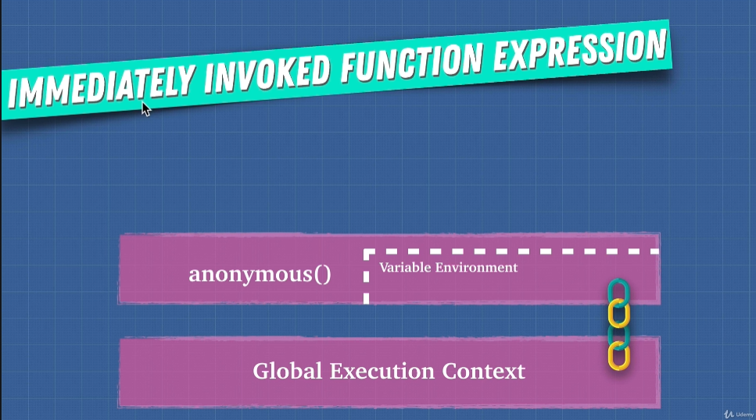

This keyword



Advantages:

1. Gives methods access to their object
2. We can execute same code for multiple objects

